2024 TAPS Management Summary

Friday, January 12, 2024

12:45 PM

**Location:**

* Colby, KS
* Valley VRI Linear

**Previous Crops and Field History**

* Tilled Fall of 2023
* Previous crop:
  + 2023: Soybean
  + 2017-2022: Corn
  + 2015-2016: Milo
  + 2014: Sunflower

**Experimental Design:**

* Randomized Complete Block Design
* Teams: 34
* Replications: 4
* Plot Dimensions: 110 ft by 12 rows

**Farm ID Map**

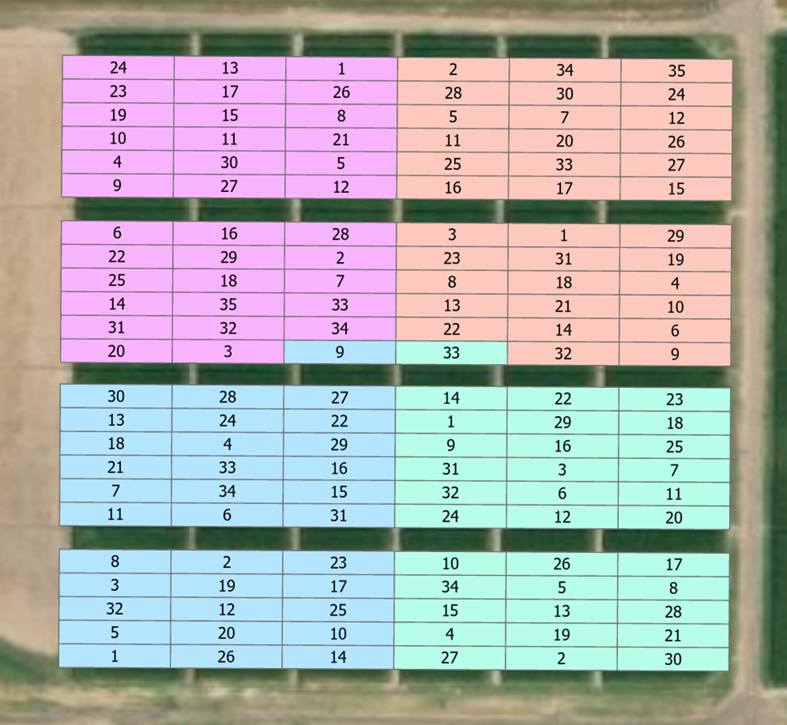

Pink = Block A; Blue = Block B; Orange = Block C; and Green = Block D

Farm (i.e., treatment) IDs are labeled

**Plot ID Map**

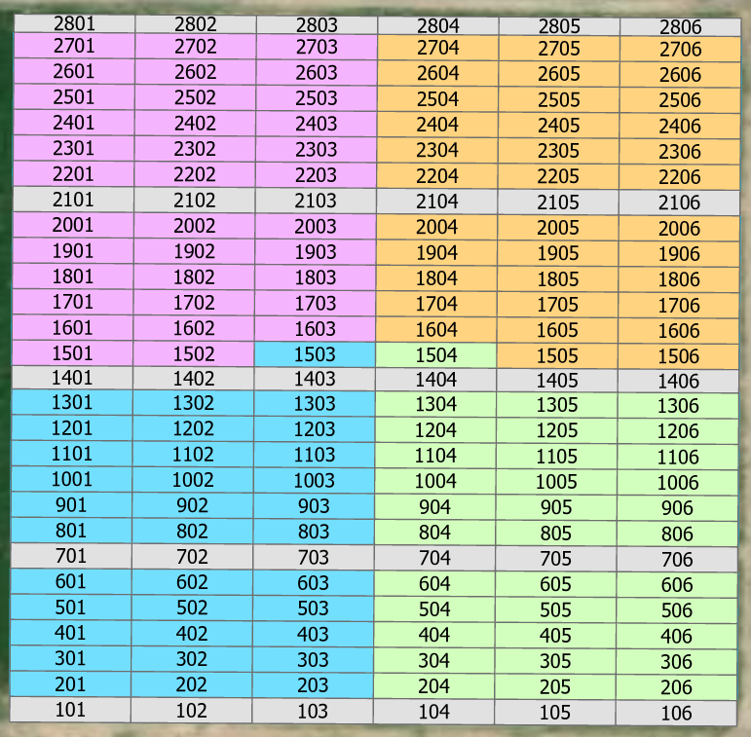

*Wheel Track plots are noted in grey

**Pesticide Management**

* Pre-Emergence Herbicide
  + Date: April 19, 2024
  + Applicator: Ray Duffey
  + Product per acre
    - AMS
    - 2.5 ounces Valor
    - 16 ounces Dicamba
    - 32 ounces Atrazine
    - 128 ounces MSO per 100 gallons

* 2nd Application
  + Date: May 22nd, 2024
  + Applicator Ray Duffey
  + Product per acre
    - Resicore: 2.5 qt/acre
    - Atrazine: 32 oz
    - Glyphosate: 32 oz
    - NIS 1 qt per gallons of water
    - 12 GPA

**Planting**

* *First Planting Date:* 
  + Date: May 7 and 8, 2024
  + Equipment: Four row precision planter
  + Speed: 2.5 mph
  + Depth: 2.25 inches
  + Row cleaners down
  + Row closers at 2nd setting of four (first left side from top)
  + Seed firmers on
  + Used prescriptions while planting

* First: Grower Hybrids
  + 23 Teams plus plots in wheel tracks (i.e., Zones 1, 7, 14, 21, and 28) and Team #35 (2 plots)
  + Blocks B and D (Zones 1 to 14) planted on May 7th.
  + Blocks A and C (Zones 15 to 28) planted on May 8th
  + Randomized lengthwise strips (i.e, north or south half of each strip)

* Reference hybrid on randomized strips (i.e., north or south half of each strip of plots)
  + Hybrid: Brevant B04Z92AM @28K
  + Date: May 8th
  + Used Prescription with outside boundary set to zero
  + Reference Strips
    - Zone 1 (closest to irrigation cart): South
    - Zone 2: North
    - Zone 3: South
    - Zone 4: South
    - Zone 5: North
    - Zone 6: South
    - Zone 7: North
    - Zone 8: South
    - Zone 9: South
    - Zone 10: North
    - Zone 11: North
    - Zone 12: South
    - Zone 13: North
    - Zone 14: South
    - Zone 15: South
    - Zone 16: North
    - Zone 17: North
    - Zone 18: North
    - Zone 19: South
    - Zone 20: South
    - Zone 21: North
    - Zone 22: South
    - Zone 23: North
    - Zone 24: North
    - Zone 25: South
    - Zone 26: North
    - Zone 27: South
    - Zone 28 (Overhang): North

* *Second Planting Date:* 
  + Date: May 15, 2024
  + Equipment: Four row precision planter
  + Speed: 2.5 mph
  + Depth: 2.25 inches
  + Row cleaners down
  + Row closers at 2nd setting of four (first left side from top)
  + Seed firmers on
  + Used prescriptions while planting

* Grower Hybrids
  + 8 Teams
  + Randomized lengthwise strips (i.e, north or south half of each strip)

* Reference hybrid on randomized strips (i.e., north or south half of each strip of plots)
  + Hybrid: Brevant B04Z92AM @28K
  + Used Prescription with outside boundary set to zero

* Bordering plots (2 rows on each side of plot boundaries)
  + Hybrid: Brevant B04Z92AM @28K
  + Used Prescription with outside boundary set to zero

* *Third Planting Date:* 
  + Date: May 29, 2024
  + Equipment: Four row precision planter
  + Speed: 2.5 mph
  + Depth: 2.25 inches
  + Row cleaners down
  + Row closers at 2nd setting of four (first left side from top)
  + Seed firmers on
  + Used prescriptions while planting

* Grower Hybrids
  + 3 Teams
  + Randomized lengthwise strips (i.e, north or south half of each strip)

* Reference hybrid on randomized strips (i.e., north or south half of each strip of plots)
  + Hybrid: Brevant B04Z92AM @28K
  + Used Prescription with outside boundary set to zero

**Nutrient Management**

* Dry Phosphorous Blend
  + Date: April 24, 2024
  + Applicator: Nutrien
  + Product lbs per acre:
    - Details: Zinc Sulfate 35: 11.76 lbs/ac
    - 12-40-0-10S 1Z Mesz: 101.76 lbs/ac
  + Analysis: 12 N, 40 P, 10 S, 5 Zn

* Pre-Plant Nitrogen
  + Date: April 24-25, 2024
  + Product: UAN 32%
  + Applicator: Lucas Haag
  + Method: Double coulter liquid applicator applying 7.5 inches on each side of the crop row at a depth of 3-4 inches.
  + Details: Applied using a prescription file.

* Sidedress
  + Date: June 21, 2024
  + Product: UAN 32%
  + Applicator: Daran Rudnick
  + Method: 360 Y Drops
  + Details: Applied at a speed of 4 mph using a prescription file.

* Fertigations
  + Dates: July 9, July 16, July 22, and Aug 6
  + Details: Maximum amount allowed was 30 lbs/ac accompanied with 0.30 inches of water.
  + Method: Applied using an Agri-Inject 29.1 gph Reflex Injection Pump tethered to a badger water flow meter.

* *First Planting Date: May 7-8, 2024*

* Starter Fertilizer
  + Date: May 7 and 8, 2024
  + Method: In-furrow
  + Applicator: Daran Rudnick
  + Application Rate: 8 gallons per acre
  + Product:
    - Riser: 2 gallons per acre
    - 10-34-0: 2 gallons per acre
    - Water: 4 gallons per acre
  + Analysis (lbs/ac): 7.25N 23P 1.2K  .3Cu .08Fe .02Mn .38Zn

* At-Planting
  + Date: May 7-8, 2024
  + Product: UAN32%
  + Applicator: Daran Rudnick
  + Method: Precision Planting Conceal applying 3 inches on both sides of the planted row at a depth of 1 inch.
  + Details: Applied using a prescription file (see subpage)

* *Second Planting Date: May 15, 2024*

* Starter Fertilizer
  + Date: May 15, 2024
  + Method: In-furrow
  + Applicator: Daran Rudnick
  + Application Rate: 8 gallons per acre
  + Product:
    - Riser: 2 gallons per acre
    - 10-34-0: 2 gallons per acre
    - Water: 4 gallons per acre
  + Analysis (lbs/ac): 7.25N 23P 1.2K  .3Cu .08Fe .02Mn .38Zn

* At-Planting
  + Date: May 15, 2024
  + Product: UAN32%
  + Applicator: Daran Rudnick
  + Method: Precision Planting Conceal applying 3 inches on both sides of the planted row at a depth of 1 inch.
  + Details: Applied using a prescription file (see subpage)

* *Third Planting Date: May 29, 2024*

* Starter Fertilizer
  + Date: May 29, 2024
  + Method: In-furrow
  + Applicator: Daran Rudnick
  + Application Rate: 8 gallons per acre
  + Product:
    - Riser: 2 gallons per acre
    - 10-34-0: 2 gallons per acre
    - Water: 4 gallons per acre
  + Analysis (lbs/ac): 7.25N 23P 1.2K  .3Cu .08Fe .02Mn .38Zn

* At-Planting
  + Date: May 29, 2024
  + Product: UAN32%
  + Applicator: Daran Rudnick
  + Method: Precision Planting Conceal applying 3 inches on both sides of the planted row at a depth of 1 inch.
  + Details: Applied using a prescription file (see subpage)

**Nitrogen Summary:**

|  |  |  |  |  |  |  |  |  |  |  |  |  |
| --- | --- | --- | --- | --- | --- | --- | --- | --- | --- | --- | --- | --- |
| **Farm** | **Planting** | **Company** | **Planting** | **P-Blend** | **Pre** | **Starter** | **At-Plant** | **Sidedress** | **V9**  **7/9/24** | **V12**  **7/16/24** | **VT/R1**  **7/22/24** | **R2**  **8/6/24** |
| **ID** | **Date** | **Hybrid** | **Date** | **(lbs/ac)** | **(lbs/ac)** | **(lbs/ac)** | **(lbs/ac)** | **(lbs/ac)** | **(lbs/ac)** | **(lbs/ac)** | **(lbs/ac)** | **(lbs/ac)** |
| 1 | 5/31/24 | Channel 214-78DGVT2PRIB | 33,000 | 12 | 225 | 7.25 | 0 | 0 | 0 | 0 | 0 | 20 |
| 2 | 5/8/24 | AgVenture AV8614AM | 24,000 | 12 | 100 | 7.25 | 80 | 60 | 0 | 0 | 0 | 15 |
| 3 | 5/8/24 | Axis 63F60 SSPRIB | 23,500 | 12 | 0 | 7.25 | 58 | 60 | 0 | 0 | 0 | 0 |
| 4 | 5/8/24 | Pioneer P1122AML | 28,000 | 12 | 0 | 7.25 | 0 | 0 | 0 | 0 | 0 | 0 |
| 5 | 5/8/24 | Pioneer P1122AML | 26,500 | 12 | 0 | 7.25 | 60 | 101 | 0 | 0 | 30 | 30 |
| 6 | 5/15/24 | Pioneer P1122AML | 25,000 | 12 | 0 | 7.25 | 140 | 0 | 0 | 0 | 0 | 0 |
| 7 | 5/8/24 | Pioneer P0859AM | 31,000 | 12 | 0 | 7.25 | 180 | 0 | 0 | 20 | 0 | 20 |
| 8 | 5/8/24 | Pioneer P1122AML | 24,000 | 12 | 0 | 7.25 | 100 | 0 | 0 | 25 | 0 | 0 |
| 9 | 5/8/24 | Dekalb DKC61-41 | 22,000 | 12 | 0 | 7.25 | 160 | 0 | 0 | 0 | 0 | 0 |
| 10 | 5/8/24 | DynaGro D54VC14RIB | 28,000 | 12 | 0 | 7.25 | 30 | 0 | 30 | 30 | 30 | 30 |
| 11 | 5/8/24 | Pioneer P1122AML | 24,000 | 12 | 0 | 7.25 | 75 | 0 | 30 | 30 | 30 | 0 |
| 12 | 5/15/24 | Golden Harvest G10L16 DV | 26,000 | 12 | 0 | 7.25 | 120 | 0 | 0 | 30 | 0 | 30 |
| 13 | 5/15/24 | Channel 204-54TRERIB | 23,000 | 12 | 0 | 7.25 | 90 | 0 | 30 | 30 | 30 | 30 |
| 14 | 5/8/24 | AgriGold A643-52VT2RIB | 28,000 | 12 | 75 | 7.25 | 0 | 0 | 0 | 30 | 30 | 30 |
| 15 | 5/8/24 | Dekalb DKC108-64RIB | 25,000 | 12 | 0 | 7.25 | 180 | 0 | 0 | 0 | 0 | 0 |
| 16 | 5/8/24 | Channel 200-48VT2PRIB | 23,000 | 12 | 0 | 7.25 | 180 | 0 | 30 | 25 | 0 | 0 |
| 17 | 5/8/24 | Channel 213-19VT2 | 28,000 | 12 | 0 | 7.25 | 70 | 100 | 0 | 30 | 30 | 0 |
| 18 | 5/31/24 | Dekalb DKC105-33RIB | 28,000 | 12 | 0 | 7.25 | 50 | 0 | 30 | 30 | 30 | 30 |
| 19 | 5/15/24 | Golden Harvest G10L16 DV | 22,000 | 12 | 0 | 7.25 | 180 | 0 | 0 | 0 | 30 | 0 |
| 20 | 5/15/24 | Pioneer P1366AML | 30,000 | 12 | 0 | 7.25 | 110 | 0 | 0 | 0 | 0 | 30 |
| 21 | 5/8/24 | Beck's 6414V2P | 24,000 | 12 | 0 | 7.25 | 80 | 0 | 10 | 15 | 0 | 15 |
| 22 | 5/31/24 | Beck's 5864AM | 24,000 | 12 | 70 | 7.25 | 50 | 0 | 30 | 30 | 0 | 0 |
| 23 | 5/8/24 | Pioneer P1122AML | 36,000 | 12 | 0 | 7.25 | 90 | 0 | 30 | 0 | 30 | 30 |
| 24 | 5/8/24 | Channel 212-02VT2PRIB | 25,000 | 12 | 0 | 7.25 | 80 | 0 | 30 | 30 | 30 | 30 |
| 25 | 5/8/24 | Golden Harvest G16Q82 DV | 28,000 | 12 | 0 | 7.25 | 120 | 0 | 0 | 25 | 25 | 25 |
| 26 | 5/8/24 | Pioneer P1122AML | 25,500 | 12 | 60 | 7.25 | 25 | 30 | 30 | 0 | 0 | 30 |
| 27 | 5/15/24 | Pioneer P1366AML | 34,000 | 12 | 0 | 7.25 | 140 | 0 | 30 | 30 | 30 | 30 |
| 28 | 5/15/24 | DynaGro D56TC44RIB | 28,000 | 12 | 0 | 7.25 | 180 | 40 | 0 | 0 | 0 | 0 |
| 29 | 5/15/24 | Pioneer P1366AML | 28,000 | 12 | 0 | 7.25 | 80 | 80 | 0 | 30 | 0 | 30 |
| 30 | 5/8/24 | Pioneer P1122AML | 26,000 | 12 | 0 | 7.25 | 70 | 40 | 0 | 0 | 0 | 0 |
| 31 | 5/8/24 | Channel 212-02VT2PRIB | 28,000 | 12 | 0 | 7.25 | 180 | 0 | 0 | 0 | 0 | 0 |
| 32 | 5/8/24 | Brevant B04Z92AM | 28,000 | 12 | 0 | 7.25 | 30 | 0 | 0 | 30 | 30 | 0 |
| 33 | 5/8/24 | Brevant B04Z92AM | 28,000 | 12 | 0 | 7.25 | 30 | 0 | 0 | 30 | 30 | 0 |
| 34 | 5/8/24 | Brevant B04Z92AM | 28,000 | 12 | 0 | 7.25 | 90 | 0 | 0 | 30 | 30 | 0 |
| 35 | 5/8/24 | Pioneer P1122AML | 28,000 | 12 | 0 | 7.25 | 30 | 0 | 0 | 30 | 30 | 0 |

**Irrigation**

* See Irrigation Log subpage

**Harvest**

* Grower Selected Hybrids: October 15, 2024
* Reference Hybrids: October 16, 2024
* Delta Wintersteiger Combine
* Harvested center two rows
* Calibration performed by Raenette Martin and Ray Duffey following Harvest Master Technician, Kip's, guidance.
* Plot lengths and stand counts of the harvest area for all plots collected on October 14, 2024

**Data Collection**

* Growth Stage

See subpage

* Soil Apparent Electrical Conductivity
  + Date: March 20, 2024
  + Equipment: Veris MSP3
  + Operator: Ross Unruh
  + Transect width: Each transect is spaced around 30 feet. Direction of travel north to south.
  + Sampling frequency: Keeping a constant speed of 3 miles per hour, the EC and OM sensors collected data after every 5.5’-6’, whereas the pH sensor collected data after every 60’-65’.

* Soil Nutrient Analysis
  + Date: March 26, 2024
  + Operator: Raenette Martin
  + Four samples per quadrant
  + Depths: 0 to 8 inches and 8 to 24 inches
  + Analysis: Complete Test: Nitrate-nitrogen, Phosphorus, Potassium, Sulfur, Calcium, Magnesium, Sodium, Zinc, Iron, Manganese, Copper, Organic matter, Soil pH, Buffer pH, Soluble salts, Cation exchange capacity, Base saturation %

* Soil Physical Properties
  + Date: April 3, 2024
  + Equipment: Veris Technologies CoreScanTM
  + Operator: Eric Lund from Veris

* Soil Nitrogen Sampling
  + Date: April 22, 2024
  + Location: Six random spots in the field (GPS coordinates recorded)
  + Depths: 0 to 10 ft in increments of 12 inches
  + Applicator: Raenette Martin and Ray Duffey
  + Equipment: Hydraulic Probe
  + Analysis: Nitrate and Ammonium

* Deep soil samples for textural properties
  + Date: May 29-30, 2024
  + Location: 10 random plots in the field (GPS coordinates recorded)
    - Plot ID's: 2401, 2403, 2405, 1203, 1706, 1802, 1105, 2604
  + Depths: 0 to 10 ft in increments of 12 inches
  + Applicator: Raenette Martin and Ray Duffey
  + Equipment: Hydraulic Probe

* Surface soil samples
  + Date: August 1-2, 2024
  + Location: All plots in block 1 and 4
  + Depth: 0 to 12 inches.
    - Two samples taken from the center of each plot. Mixed and added to the sampling bag
  + Applicator: Simon and Raenette Martin
  + Equipment: Push probe
  + Analysis: pH, OMC%, nitrate, phosphorus, potassium, sulfur, calcium, magnesium, sodium, zinc iron, manganese, copper, boron, and CEC

* Soil Moisture at or near Planting
  + Date:
    - Planting I: May 8, 2024
    - Planting II: May 16, 2024
    - Planting III: May 30, 2024
  + Location: Thirty random locations in the field
  + Depth: Top 12 cm
  + Equipment: Campbell Scientific CS659 using HydroSense II logger
  + Data: Located in OneNote subpages

* Biomass and Grain Sampling
  + October 10, 2024
  + Twelve plants
    - 3 plants from row 1, 3 plants from row 2, 3 plants from row 3, and 3 plants from row 4
    - Need to add back half the grain weight to the combine harvest data (*except for plot 206, which all weight needs to be added to the combine weight)

* Stover:
  + Total bundle weight edge of field
  + Total bundle weight at Ward labs
  + Dry matter % at Ward
  + Dry matter N % at Ward
* Shelled Ears:
  + Wet grain weight by team
  + Moisture Content
  + Grain dry matter N % at Ward
* Cobs
  + Four random samples of 12 cobs each
  + Cob dry weight
  + Cob dry matter N %

* Stover samples delivered to Ward Labs on October 11, 2024
* Grain and cob samples delivered to Ward Labs October XX, 2024

* Drone Imagery
  + Details: Sensor is a RedEdge-P. The drone is a DJI S900 with a Pixhawk Cube flight control system.
  + Collector: Ray Duffey
  + Dates:
    - 5/16/24
    - 6/11/24
    - 7/10/24
    - 7/23/24
    - 8/1/24
    - 8/22/24
    - 9/23/24

* Gas Analyzer
  + Nitrous Oxide, Methane, Carbon Dioxide, and Water
  + Treatments: 32, 33, and 34 (3 reps each)
  + Applicator: Rayhaan Kabenge
  + Dates:
    - 8/14/24
    - 8/16/24

* Neutron Tube Installation
  + Date: May 20, 2024
    - 24 tubes (Zones: 8, 10, 16, and 19)
  + Dates: May 29-30, 2024
    - Remaining tubes
  + All 138 plots have a neutron tube in center of plot
  + GPS points collected

* Cosmic Ray Probe and LI-COR 710 Sensor
  + Date: May 20, 2024
  + Location: Center of TAPS field (Zone 15 and west edge of column 4)
  + Trenton Franz from UNL helped install the unit (see pictures in Instrumentation subpage)

* Sentek Soil Moisture Sensors
  + Date: May 28, 2024
  + Team #'s: 3, 9, 10, 16, 17, 23, 29, 30, 32, 33, and 34
  + Location: Block D

|  |  |  |
| --- | --- | --- |
| **Team #** | **Longitude** | **Latitude** |
| Team 3 | -101.06464 | 39.3857216 |
| Team 9 | -101.06509 | 39.3858061 |
| Team 10 | -101.06508 | 39.3854142 |
| Team 16 | -101.06464 | 39.3857969 |
| Team 17 | -101.0643 | 39.385417 |
| Team 23 | -101.06428 | 39.3859663 |
| Team 29 | -101.06465 | 39.3859061 |
| Team 30 | -101.0643 | 39.3850602 |
| Team 32 | -101.06508 | 39.3856686 |
| Team 33 | -101.06507 | 39.3861495 |
| Team 34 | -101.06506 | 39.3853047 |

* Installed by Ben Fullner, Bob Gills, and Daran Rudnick

* GroGuru Soil Moisture Sensors
  + Date: May 29, 2024
  + Team #'s: 4, 7, 16, and 20
  + Location: Block D and Bulk Soybean Area

|  |  |  |
| --- | --- | --- |
| **Team #** | **Longitude** | **Latitude** |
| Team 20 | -101.06425 | 39.3855925 |
| Team 7 | -101.06429 | 39.38569 |
| Team 16 | -101.06466 | 39.3858022 |
| Team 4 | -101.06507 | 39.3851583 |

* Installed by Caleb Dechant

* CropX Soil Moisture Sensors
  + Date: June 5, 2024
  + Team #'s: 4, 11, 16, and 24
  + Location: Block D

|  |  |  |
| --- | --- | --- |
| **Team #** | **Longitude** | **Latitude** |
| Team 11 | -101.06429 | 39.3856636 |
| Team 16 | -101.0647 | 39.3857985 |
| Team 24 | -101.06508 | 39.3855864 |
| Team 4 | -101.06507 | 39.3851744 |

* Installed by Brian Vinton

* AquaSpy
  + Date: June 7, 2024
  + Team #'s: 12, 14, 16, 25, 28, and 31
  + Location: Block D

|  |  |  |
| --- | --- | --- |
| **Team #** | **Longitude** | **Latitude** |
| Team 28 | -101.06434 | 39.3852461 |
| Team 25 | -101.06424 | 39.3858022 |
| Team 16 | -101.06458 | 39.385798 |
| Team 12 | -101.06469 | 39.3855789 |
| Team 14 | -101.06504 | 39.3859651 |
| Team 31 | -101.06502 | 39.3857231 |

* Installed by Eric Betschart's Team

* Arable Mark III's
  + Date: June 4, 2024
  + Team #'s: 2, 4, 5, 13, 15, 16, 18, 21, 22, 26, 27, and 28
  + Serial #'s:

|  |  |
| --- | --- |
| **Serial ID** | **Farm #** |
| D006451 | 15 |
| D006380  D008632 | 4 |
| D006425 | 27 |
| D006527 | 2 |
| D006561 | 13 |
| D006388 | 5 |
| D006536 | 26 |
| D006522 | 28 |
| D006418  D008677 | 21 |
| D006538 | 16 |
| D006433 | 18 |
| D006530 | 22 |

* Location: Block D

|  |  |  |
| --- | --- | --- |
| Team # | Longitude | Latitude |
| Team 13 | -101.06472 | 39.38524 |
| Team 15 | -101.06509 | 39.38525 |
| Team 16 | -101.06473 | 39.38587 |
| Team 18 | -101.0643 | 39.38589 |
| Team 2 | -101.06472 | 39.38508 |
| Team 21 | -101.06431 | 39.38519 |
| Team 22 | -101.06472 | 39.386 |
| Team 26 | -101.0647 | 39.38539 |
| Team 27 | -101.06507 | 39.38509 |
| Team 28 | -101.06431 | 39.38532 |
| Team 4 | -101.06508 | 39.38517 |
| Team 5 | -101.06473 | 39.38535 |

* Installed by Ray Duffey and Simon